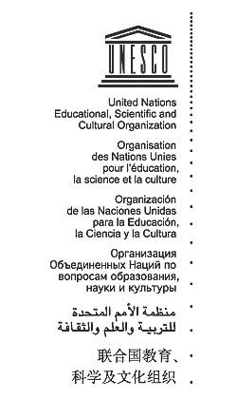
UNESCO Photo Library
Bureau of Public Information

Photothèque de l’UNESCO
Bureau de l’Information du Public

AGREEMENT GRANTING NON-EXCLUSIVE RIGHTS

Reference: Proud to Share Film 2020

- a. I the undersigned, copyright-holder of the above-mentioned photo(s)/ video(s) hereby grant to UNESCO free of charge the non-exclusive right to exploit, publish, reproduce, diffuse, communicate to the public in any form and on any support, including digital, all or part of the photograph(s)/ video(s) and to license these rights to third parties on the basis of the rights herein vested in UNESCO

- These rights are granted to UNESCO for the legal term of copyright throughout the world.

- The name of the photographer/author/copyright holder will be cited alongside UNESCO’s whenever his/her work is used in any form.

- UNESCO is an Open Access publisher and the UNESCO publications are made available on-line, free of charge through UNESCO’s documentary repository. Any commercialization of its publications by UNESCO is for cost-recovery of nominal actual costs for printing or copying content on paper or CDs, and distribution. There is no profit motive.

- I certify that:

  - I am the sole copyright holder of the photo(s)/ video(s) and am the owner of the rights granted by virtue of this agreement and other rights conferred to me by national legislation and pertinent international conventions on copyright and that I have full rights to enter into this agreement.

  - The photo(s)/ video(s) is/are in no way whatever a violation or an infringement of any existing copyright or license, and contain(s) nothing obscene, libelous or defamatory.

  - I will hold UNESCO harmless against any third parties who may bring lawsuits or legal actions against UNESCO based on their alleged rights in the photo(s)/ video(s).

- All disputes arising out of, or in connection with the present agreement or the breach thereof, shall be settled primarily by mutual understanding. In the event an amicable settlement cannot be reached, such dispute shall be settled by binding arbitration of a sole arbitrator in accordance with the rules of arbitration of the United Nations Commission on International Trade Law (UNCITRAL) as at present in force. The arbitration shall be final and binding.

Name and Address: Date:
Signature:

(Please sign, return to UNESCO one copy of the Agreement and retain the original for yourself)
Mailing address: 7 Place Fontenoy, 75352 Paris 07 SP, Telephone: +33 1 45680709
E-mail: n.lefebvre@unesco.org

